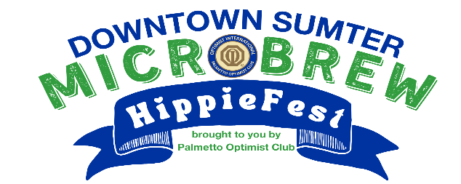

Sumter Microbrew Sponsorship Form

Mark your calendars for Friday, May 10th, 2024, from 6-8:30 pm for the Downtown Sumter
Microbrew Festival, brought to you by the Palmetto Optimist Club, sponsored by the Yahnis Company, and helping the youth of Sumter. This year, pull out your bell bottoms and tie-dye t-shirts, because we’re going back to the ‘60s with HippieFest!

We have attached a “flight” of sponsor recognition and benefits and would love for you to consider a sponsorship at some level in support of the youth in our community.

We expect to have 10-12 participating locations who will host 2 different microbrew beers from selected breweries that participants can taste. Each location will have food, decorations and signs listing the Growler, Pony, Key and sponsors.

If your business is interested in sponsoring this year’s event, please send the form below on or before March 31, 2024.

Pilsner- $100
- Recognition on Palmetto Optimist website
- Recognition on Palmetto Optimist Facebook page

Pitcher- $300
- Recognition on Palmetto Optimist website
- Recognition on Palmetto Optimist Facebook page
- Logo placed on Microbrew maps and flyers.

Growler-$500
- Recognition on Microbrew Palmetto Optimist & Facebook page
- Logo placed on Microbrew maps, flyers and signs in front of businesses at the event.
- 2 Microbrew tickets

Pony – $750
- Recognition on Palmetto Optimist website & Facebook page
- Logo placed on Microbrew maps, flyers and signs in front of businesses at the event.
- 4 Microbrew tickets
- Logo on Microbrew tasting cup. (First Come First Serve)

Keg- $1000
- Recognition on Palmetto Optimist website & Facebook page
- Logo placed on Microbrew maps, flyers and signs in front of businesses at the event.
- 6 event tickets to Microbrew
- Logo on Microbrew bag (First Come First Serve)

Sumter Microbrew Sponsorship Form

Name: ____________________________________________________________________________________
Business: __________________________________________________________________________________
Address: __________________________________________________________________________________
Phone Number: ____________________________________________________________________________
Email Address: _____________________________________________________________________________
Sponsor Level (Check one):

- Pilsner -$100
- Pitcher - $300
- Growler - $500
- Pony - $750
- Keg - $1000

Cup and Bag Sponsors must be confirmed in advance. First Come First Serve

Thank you!

Please make check payable to and return form to:
Palmetto Optimist Club
1390 Malone Drive
Sumter, SC 29154
PalmettoOptimistClub@gmail.com
Questions? Call Linda (803) 236-4506

